Please Print for Your Records
Name______________________________________________
Entering Grade Fall____________________ Age__________
Middle School & Town________________________________
Home Address_______________________________________
Parent(s)/Guardian___________________________________
Email Address (neatly please!)_________________________
Home Phone___________________ Cell__________________
Circle ADULT T-shirt Size: S M L
Circle Week: 1st Week 2nd Week
Waiver Of Claims:
I, as Parent/Guardian, give permission for my child to participate in the Cougar Volleyball Camp 2018 and waive any claim that I might have against Arlington Catholic and the coaches of the camp.

Signature of Parent/Guardian

Print Name
Special Circumstances? (Allergies, Asthma…etc) Email Coach Reis- coachreis@aol.com
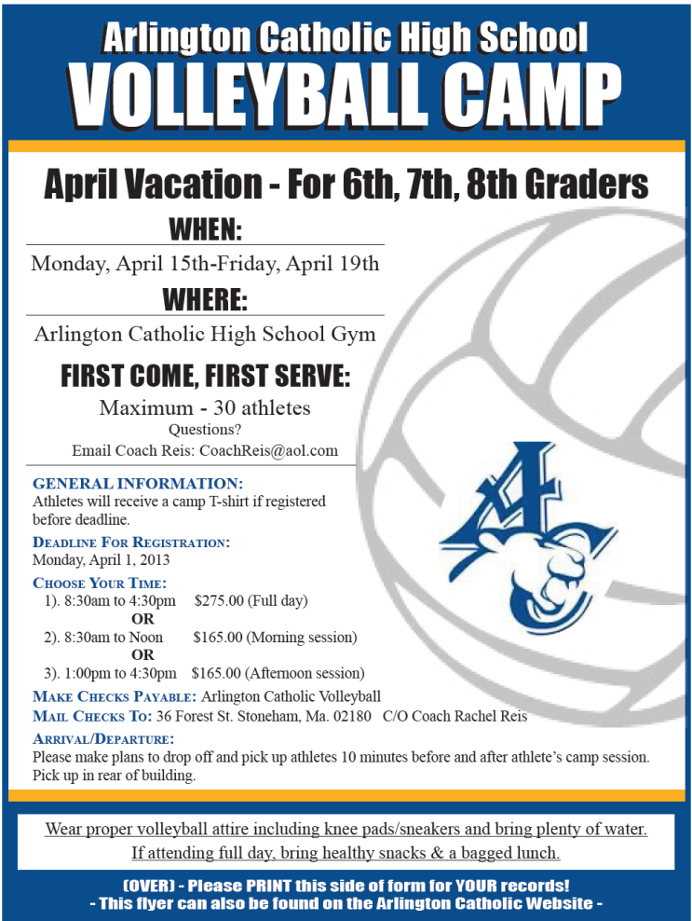
July 23rd – 27th and/or July 30th – August 3rd : 3pm – 6pm
DAYS ARE SUBJECT TO CHANGE DUE TO GYM SCHEDULING CONFLICTS.
***Please drop off and pick up athletes in the rear of the building.***

General Information
Athletes will receive a camp T-shirt Please register by July 9, 2018
Cost
$185.00 for 1 week or $295 for both
Make Check Payable:
Arlington Catholic High School
Mail Checks To:
36 Forest St. Stoneham Ma. 02180
C/O Coach Rachel Reis

Arlington Catholic High School Gym
For Entering 7th, 8th, and 9th Graders

